

**Provisioning Template to Delete All Expired SSL Certificates**

**User Guide**

|  |  |  |
| --- | --- | --- |
| **Version** | **Remarks** | **Date** |
| **1.0** | **Provisioning Template User Guide for Deleting all Expired SSL Certificates** | **25/01/2017** |
| **2.0** | **Updated document with installation of the template.** | **14/02/2017** |
|  |  |  |
|  |  |  |

## Installation of the Template and Helper Script

1. Login to AppViewX.
2. On the left navigation menu, select ***Provisioning***; and click ***Template.***
3. On the upper right portion of the screen click on the  Import button.
4. The following screen will appear. 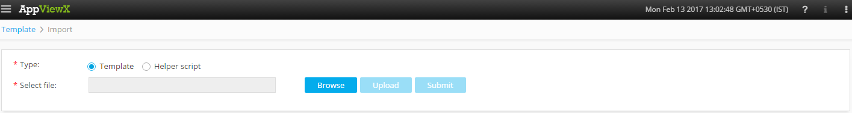
5. Please Select Template/Helper Script.  
   If Template is chosen,
   1. Click on *Browse* and select the Zip File of the template which has to be installed/imported and click open.
   2. Click on upload to import the Zip file and display the templates present in the zip file.
   3. Click on submit to deploy the templates into the AppViewX Environment.

If Helper Script is chosen,

1. Click on *Browse* and select the Zip File of the Helper script which has to be installed/imported and click open.
2. Click on upload to import the Zip file and display the Helper Scripts present in the zip file.
3. Click on submit to deploy the Helper Scripts into the AppViewX Environment.

## Delete expired SSL Certificates.

1. Login to AppViewX.
2. On the left navigation menu, select ***Provisioning***; and click ***Request.***
3. On the upper right portion of the screen, click the  ***Create*** button.
4. Select the provisioning template name from the list –‘**Delete_Expired_SSL_Certificate_Generic**’.

**Note:** *If no template is available, this indicates that the user role does not have permission to the requesting template.*

1. Enter the provisioning request description – ‘Deleting Expired SSL Certificate’.
2. Add a default Request scenario name relevant to the template. ***E.g***.: Deleting Expired SSL Certificate.
3. Click on ‘***Get F5 Device***’ button to fetch the available list of F5 devices in the inventory.
4. In the **Device** field, list of F5 devices are populated. Please select the **F5** device on which the Expired certificates are present.
5. Click on ‘***Get Expired Cert***’ button to fetch the available list of Expired certificates in the inventory.
6. In the **Expired Cert** field, list of Expired certificates are present, Please select the certificate which has to be deleted.
7. Click on ‘***Get Profile with Expired Cert***’ button to fetch the Profile associated with the Expired Certificate.
8. Click on *Submit* to generate work order(s) for the provisioning request.